

Ben-Gurion University of the Negev
Faculty of Engineering Science
School of Electrical and Computer Engineering
Dept. of Electrical and Computer Engineering
Fourth Year Engineering Project
PDR
 | p-2026-157 | Project number:
 | Ido shlomy and yizhar fahima  315095448 and 208066381 | Students  (name & ID):
 | Dr. Greenberg Shlomo and Mr. Manor Erez | Supervisors:
 |  | Sponsors:
 | 2025-11-03 | Submitting date:
Implementation of Quantum Key Distribution (QKD) in Free-Space
Ido Shlomi and Yizhar Fahima
idoshlom@post.bgu.ac.il and yizharf@post.bgu.ac.il
Adviser: Dr. Greenberg Shlomo
Contents
Abstract
תקציר
1. Problem Definition
2. Literary Review
3. Proposed Method
4. Research Proposal
5. Bibliography

Abstract
Driven by the growing demand for secure communications, Quantum Key Distribution (QKD) offers a security layer leveraging the principles of quantum mechanics. Free-Space Optical Communications (FSOC) provide a promising platform for data transmission; however, atmospheric turbulence distorts the optical wavefront and hinders reliable information recovery.
The goal of this project is to develop a simulation of an adaptive optics (AO) system that reconstructs the wavefront prior to atmospheric propagation, thereby enabling long-range free-space QKD (ground-to-satellite) FSOC . The system will be implemented in Python using the HCIPy library. We will evaluate system parameters and transmission quality metrics, and integrate both physical and statistical models to characterize turbulence effects and design an effective correction loop.
Our primary channel-quality metric is the bit error rate (BER), defined as the probability of incorrectly decoding a single transmitted bit.
Our objective is to design a system that minimizes this metric to provide a reliable communication channel.
key words: Quantum Key Distribution, hcipy, python, Adaptive Optics, turbulence, Bit Error Rate

תקציר
בעקבות הביקוש ההולך וגובר לתקשורת מאובטחת, חלוקת מפתחות קוונטית (QKD) מציעה שכבת אבטחה הנשענת על עקרונות מכניקת הקוונטים. תקשורת אופטית בחלל חופשי (FSOC) מהווה פלטפורמה מבטיחה להעברת נתונים, אך טורבולנציה אטמוספרית פוגעת בחזית הגל ומקשה על שחזור אמין של המידע.
מטרת הפרויקט היא לפתח סימולציה למערכת אופטיקה אדפטיבית המשחזרת את חזית הגל לפני המעבר באטמוספרה, ובכך מאפשרת QKD בערוץ חופשי ארוך-טווח (קרקע–לוויין).
המערכת תמומש בסימולציות Python באמצעות ספריית HCIPy. נבחן פרמטרים מערכתיים ומדדי איכות שידור, כמו כן נשלב מודלים פיזיקליים וסטטיסטיים לתיאור השפעות הטורבולנציה ותכנון לולאת תיקון יעילה.
המדד העיקרי שלנו לאיכות הערוץ הוא (BER (bit error rate המסמל את ההסתברות של אי הצלחת שידור בודד של ביט מידע. מטרתנו היא לבנות מערכת המצליחה למזער מדד זה ובכך לאפשר היתכנות של ערוץ תקשורת אמין.
מילות מפתח:QKD, hcipy, python,אופטיקה אדפטיבית,טורבולנציה, יחס שגיאה לאות

Problem Definition

Although Quantum Key Distribution (QKD) in Free space optic communication(FSOC) has been extensively researched, the practical implementation of a system with a real-time photon detection remains an unobtained task. Our main challenge is to overcome the effect of the randomly changing atmosphere on the signal’s distortion. We intend to implement an AO method to be able to create a reliable optic channel for ground to satellite communication.
The system consists of a transmitted beam generator, a reference beam generator and a deformable mirror array. In our project we will simulate the channel using the hcipy library to create a POC for a real ground to satellite communication system.with aspiration that one will build a practical qkd fsoc.

Literary Review

Adaptive Optics:
Adaptive Optics (AO) is a technique employed in Free Space Optical communication (FSOC) systems to deal with distortions.
Based on its application in FSO links, AO is used for the evaluation of channel capacitie.It provides real-time wavefront correction.
It has been investigated as a means to achieve simultaneous pre- and post-turbulence compensation. The need for compensation stems from the fact that transmitted optic signals are subject to atmospheric turbulence-induced distortions that can deteriorate the entire FSO if not properly addressed.
In essence, AO works to correct the degradation of optical signals caused by atmospheric turbulence, thereby improving the reliability and performance of the communication link[1].

  - QKD
Quantum Key Distribution (QKD) is a cryptographic technique utilizing the principles of quantum mechanics to enable secure communication through the distribution of a secret key between two parties. The security of QKD is derived from the intrinsic laws of physics. Specifically, QKD protocols exploit the fundamental principle that measuring a quantum system inevitably causes a detectable disturbance in its state, thereby allowing the immediate detection of any unauthorized interception of the key. QKD protocols, such as the BB84 variant, employ quantum properties like superposition and quantum entanglement to establish these secure communication channels.[2]

Turbulence
Small-scale fluctuations in air temperature and pressure that make the refractive index 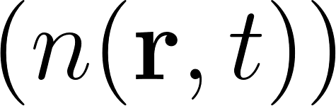 vary randomly in space and time. As light crosses this medium, its phase and amplitude wander, causing blur, beam wander, and scintillation (rapid intensity fades), which together act like random channel fading in FSO links. Turbulence strength is commonly measured by the refractive-index structure parameter 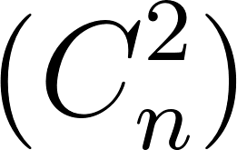 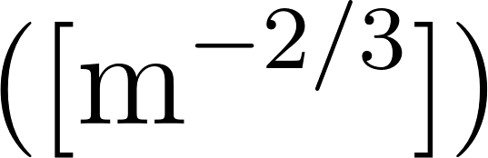:
weak 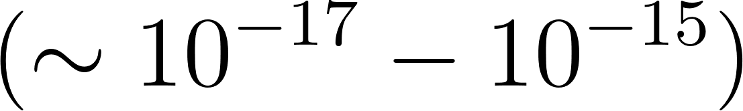
moderate 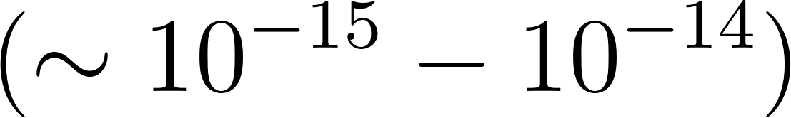,
strong 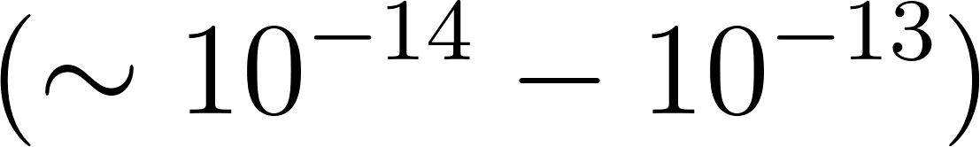.
In this project we vary  to test how robust our link remains under increasing turbulence.[1]

Proposed Method
  - Task Definitions: To achieve our objective, we divided the work into five key tasks.
    - To simulate a wavefront that propagates through a single layer that diffract the signal and change its amplitude and phase[1]
    - To achieve a clear wavefront with a multiphase screen. with fixed amplitude and phase by using wavefront[2]
    - To send through the channel a photon to achieve a QKD
    - Create a clear channel that can be used for QKD FSOC- reduce bit error rate
    - Create an adaptive channel through time to create a communication channel through long communication periods

Research Proposal
  - essence of product
The product is a proof of concept for a physical system for error detection and correction of signals in an FSOC channel. The product will rely on existing mathematical and physical models of optics and the atmosphere and will demonstrate the feasibility of a reliable FSOC channel.

  - what grade will it satisfy
The simulation of the channel will be considered reliable if it will meet the BER requirements of a standard cellular communication channel before using any detection protocol of any sort.

  - what is the input and output of the system
The input of the system will be a set of requirements and parameters that represent the current state of the environment of the channel.
The system outputs a set of simulation results such as graphs, images and tables with
data that determine the quality of the FSOC channel

  - mathematical models
In the project we will use the mathematical and physical model that hcipy[3] uses to perform their calculations and simulations. Such as Fraunhofer model for propagating a wavefront through an aperture and Shack-Hartmann WFS model for FSOC channel simulation [3]

Bibliography

[1] Knoedler, Alexander, and Florian Moll. “Atmospheric Turbulence Statistics and Profile Modeling. Local to DLR Oberpfaffenhofen.” COAT-2019 - workshop (Communications and Observations through Atmospheric Turbulence: characterization and mitigation), ONERA, Dec 2019, Châtillon, France.
[2]. Por, E. H., S. Y. Haffert, V. M. Radhakrishnan, D. S. Doelman, M. van Kooten, and S. P. Bos. “High Contrast Imaging for Python (HCIPy): an open-source adaptive optics and coronagraph simulator.” Adaptive Optics Systems VI, Proc. SPIE, vol. 10703, 2018, paper 1070342.

[3]. SujayKumar Reddy, M., and B. C. Mohan. "Comprehensive Analysis of BB84, A Quantum Key Distribution Protocol." arXiv:2312.05609, 2023. [quant-ph].

